Brendan Clarke
CS 340
Project- ReadMe

This dashboard application provides an interactive interface for exploring animal shelter data stored in MongoDB. Users can:
- Filter records by rescue scenarios (Water, Mountain/Wilderness, Disaster) via radio buttons.
- View filtered results in a sortable, paginated table.
- Visualize breed distribution with a dynamic pie chart.
- Map individual animal locations using a Leaflet map based on selected table entries.
Required Functionality
- Data filtering: The dashboard must query MongoDB based on user-selected filter criteria and display results in a Dash DataTable.
- Data visualization: A pie chart must reflect the breed distribution of the current table view.
- Geolocation mapping: Selecting a row highlights an animal marker on a Leaflet map.
- Responsive layout: Components should adjust gracefully to different browser sizes.
Proof of functionality:
- Filtering works: Choosing “Water Rescue” returns only the three specified water-retriever breeds in the DataTable (see screenshot at assets/screenshots/filter-table.png).
- Dynamic visualization: The pie chart automatically updates to reflect the current table’s breed distribution (see screenshot at assets/screenshots/pie-chart.png).
- Interactive mapping: Clicking any row places a marker at the correct coordinates on the Leaflet map (see screenshot at assets/screenshots/map-view.png).

Tools and Rationale
- Python 3.8+: Core language for scripting and library support.
- MongoDB: Chosen for its flexible document model, easy JSON-like querying, and robust Python driver (pymongo) for seamless integration.
- Dash: Provides a structured view-controller framework built on Flask and React, ideal for rapid development of interactive, web-based dashboards in pure Python.
- Plotly Express: Simplifies creation of common chart types (e.g., pie charts) with minimal code.
- dash-leaflet: Integrates Leaflet.js maps into Dash for geospatial visualization.

MongoDB as Model Component
MongoDB's schema-less design allows storing diverse animal outcome records without rigid table definitions. Key advantages:
- Query flexibility: Complex filters (e.g., age ranges, breed lists) via $gte/$lte and $in operators.
- Scalability: Handles large volumes of records efficiently.
- Python integration: The pymongo library offers direct, idiomatic use of MongoDB queries and cursors in Python scripts and Jupyter notebooks.

Dash Framework Explanation
Dash structures an application into:
- Layout (View): A tree of Dash components (html.Div, dcc.Graph, etc.) describing what the page looks like.
- Callbacks (Controller): Functions decorated with @app.callback that reactively update parts of the layout based on user inputs and component state.
- Server: A Flask server hosting both the layout and callback endpoints, enabling real-time interactivity without manual JavaScript.

Resources and Links
- MongoDB & PyMongo: https://docs.mongodb.com/python/
- Dash Documentation: https://dash.plotly.com/
- Plotly Express: https://plotly.com/python/plotly-express/
- dash-leaflet: https://github.com/thedirtyfew/dash-leaflet

Project Setup Steps
- Environment setup: Installed Python libraries (dash, pymongo, dash-leaflet, etc.).
- Database connection: Built AnimalCrud class to wrap MongoDB CRUD operations.
  - Using our AnimalCrud class, we can Add, Update, Delete entries in our database.
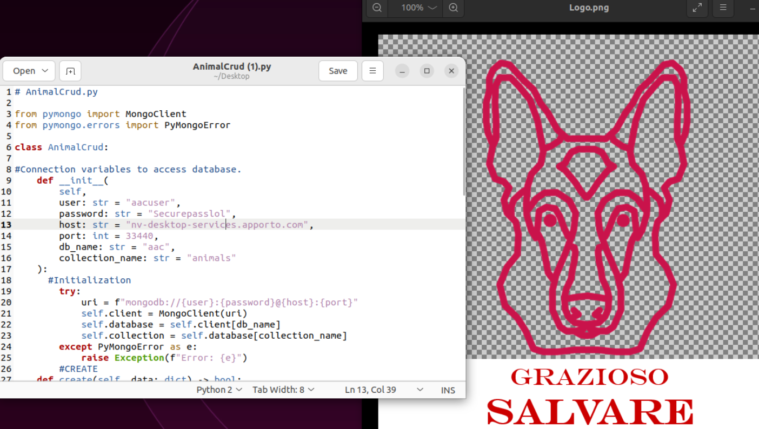
- Data loading: Setup jupyter notebook by importing the .ipynb into jupyter notebook.
  - 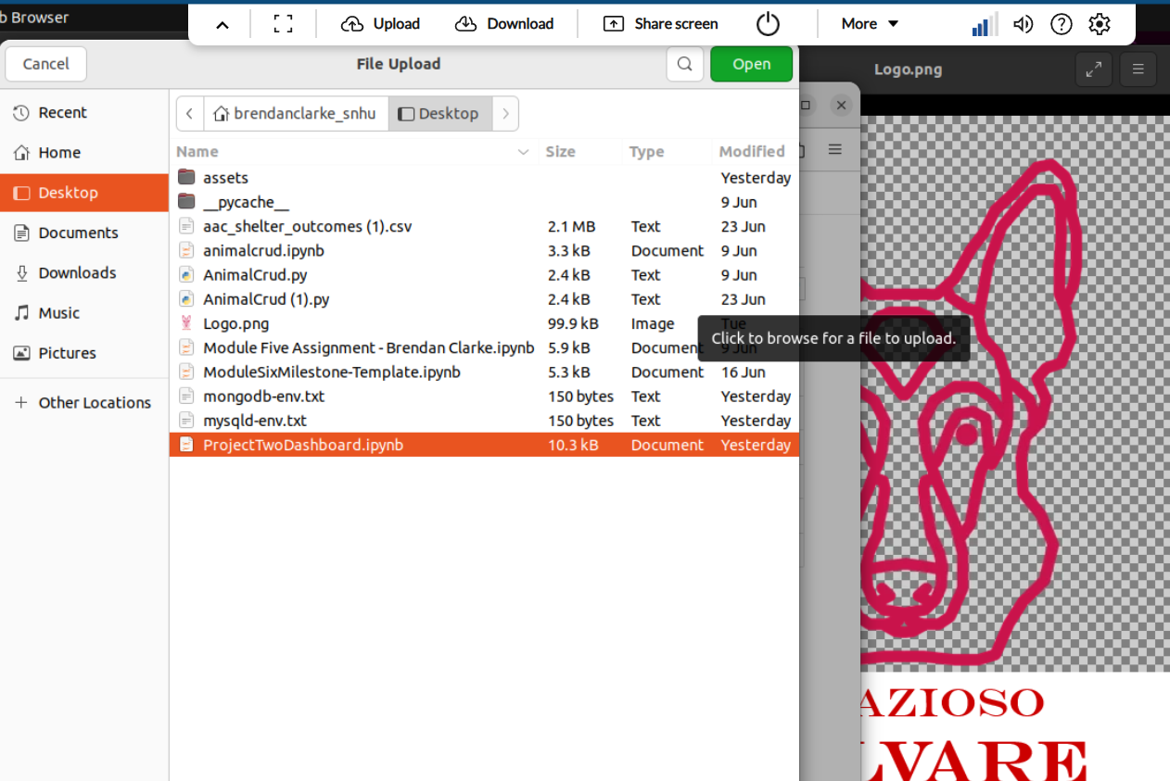
- Query mapping: Defined make_query() to translate radio-button choices into MongoDB filters.
- Layout design: Assembled Dash components for table, controls, graph, and map.
  - 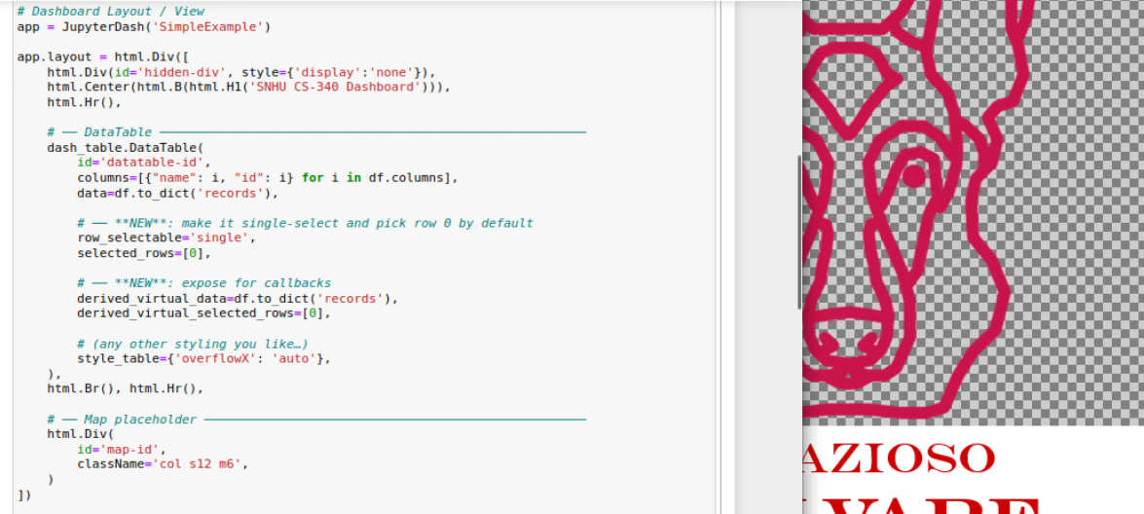
- Callbacks: Implemented reactive functions for filtering, chart updates, and map rendering.
- Testing & deployment: Verified functionality in Jupyter Notebook,
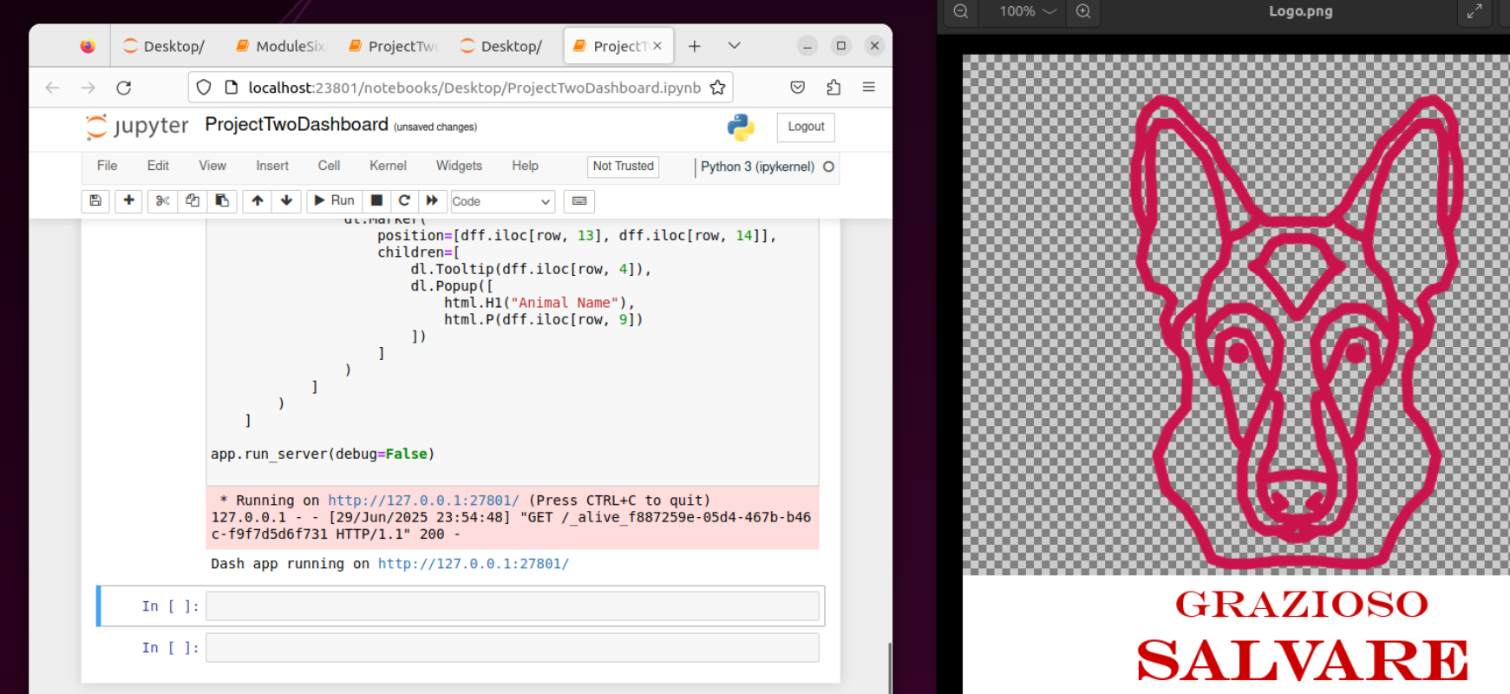

Challenges & Resolutions
- Image hosting: Serving a local logo in JupyterDash proved tricky—resolved by using Dash’s assets/ folder.
- Indentation errors: Python callbacks required consistent 4-space indentation; fixed by reformatting code blocks.
- Dynamic mapping: Ensuring correct latitude/longitude indices in DataFrame; addressed by verifying column order and types.
Further improvements: Add pagination controls on map, support custom date-range filters, and implement user authentication before dashboard access.

